Walk 32 Pembridge and Eardisland
Last walked in July 2016

Description. An 8 km (4.9 miles) walk. Herefordshire is famed for its black and white villages of which Pembridge and Eardisland are among the finest.
Start. Free car park on the R as you enter into Pembridge. Grid reference Explorer Map 201. Grid 392582.
Directions from Whitecross Roundabout (Turn milometer to zero). Take the A4110 Canon Pyne/A4113 Knighton (Three Elms road). Continue on, thru Canon Pyon, for 10.1 miles and as the road bends R you TL onto the B4457(A44) to Pembridge/Eardisland. At 11 miles go straight across the cross roads to Rhayader on the A44, also goes to Eardisland, Pembridge and Kington. At 13.6 miles you reach Pembridge, the free car park is on the R (13.9m).

1. Pembridge. Out of the car park and TL, walk about 200 yards along the main road to just pass The Old Oak House and TL onto a Public Footpath. Go thru a double wooden gate and walk down the drive on the R to a small haulage yard where you TL and go thru double metal gates and across a small field to the L hand corner where you cross over a hidden stile by a gate (the stile consists of four metal bars) and into a large field{F1}, you then cross over three wooden planks (a footbridge). Keep to the hedge/fence on your L as it turns L after about 150m and continues onto the corner of the field where you cross over a stile/metal gate into {F2}. Keeping the hedge/fence to your L, head towards some houses. TR at the end of the field by a gate near houses, and follow the field boundary, keeping the fence and a small green lane on your L. Carry on to go thru a kissing gate into {F3}then TR.

2. River Arrow. The path across these flat riverside meadows does not cling as closely to the river arrow as one may expect and desire, although the river is always on the L. At the end of {F3}, where you keep close to the hedge on your R, you cross over a wooden footbridge with a metal gate at each end into {F4}. Head straight across this field to cross over a stile into {F5}. Head in the same direction across this field, to cross over another stile into {F6}. Keep to the fence and field boundary on your R as you cross {F6} to cross over another stile into {F7}. Go straight across to cross over another stile into {F8} and a tantalising glimpse of the river at a weir. Keep to the L field boundary as you walk around to the narrow end of this large field, ignoring the first and the second concrete bridges that are on your L. At the end of the field you TR and cross over two stiles with wooden steps in the middle, into {F9} where you TL. Follow the hedge/fence on your L to cross over another stile into {F10}. Follow the fence/hedge on your L and after a short distance TL to cross over a wooden gated bridge into {F11}. Bear slightly R as you cross this field and head towards houses and the road, at the end of the field go thru a kissing gate into {F12}. Cross this small field to go thru a kissing gate and onto the main road, where you TL. You are now in Eardisland. Continue on towards the bridge that acts as a magnet for so many visitors.

3. The Dovecot. TL just before the main bridge/river and walk along the road, which is ‘Unsuitable for Long Vehicles’ and runs opposite the Dovecote. Continue along this road for about 2½ km (ignoring the road on the R, The Foley) and after about 2½ km the road does a sharp R.
Continue straight on the tarmac track on the L leading to the farmstead of Twyford.

4. Twyford. After a short distance TR thru a metal gate that’s opposite an old petrol pump. Bear half L to cross the field and then a stile/gate into another field. Continue on to the L corner of the field and cross a wooden footbridge into another field. Cross the field and then a stile onto a road. TL and continue along the road to reach a T-junction where you TL and go back to the car.
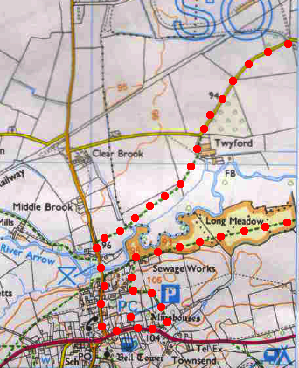
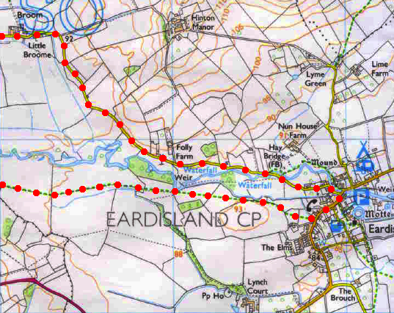
1
4
3
2

